

**At Matraville Soldiers’ Settlement Public School it is our aim to provide an anti-bullying plan supported by restorative practices that aim to:**

* ***Ensure that all members of the school community are treated with respect***
* ***Foster better relationships***
* ***Encourage staff and students to take positive steps to avoid hurting others***
* ***Reduce/eradicate bullying at Matraville Soldiers’ Settlement Public School***
* ***Promote healthy relationships***

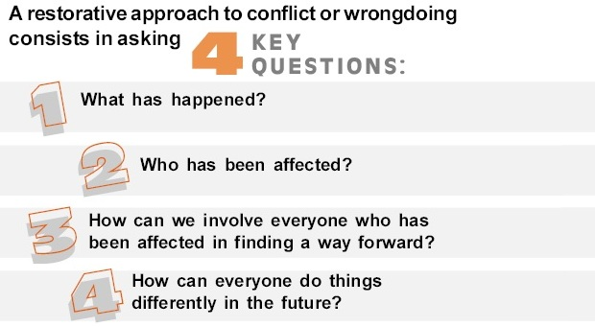

🙵

**Consequences of Bullying at Matraville Soldiers’ Settlement Public School**

At Soldiers’ Settlement we follow the principles of restorative justice in the first instance. We focus on repairing the harm done to people and relationships. The restorative approach allows the student to make amends and shed the offender label.

However, if the student does not take responsibility for the harm caused nor attempts to change their behaviour, other measures may be implemented such as:

- conferences with Assistant Principal when bullying is known to be occurring.  
  
- parents are notified by telephone and letter.  
  
- interview with parents and assistant principal or principal if bullying continues.  
  
- loss of privileges  
  
- short suspension from school.  
  
- should bullying continue, referral to school or community based counselling.  
  
- long suspension from school.  
  
- expulsion from school.

***‘Physical bullying involving violence may lead to immediate suspension’ in line with the Department of Education and Communities guidelines***

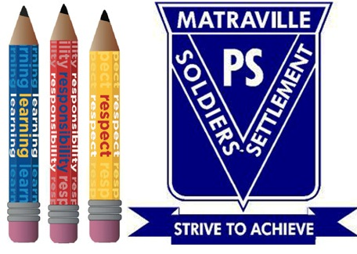

Bits, Bytes & Chips



Matraville Soldiers’ Settlement Public School Anti-Bullying Policy



***This anti- bullying plan is implemented in conjunction with the Positive Behaviour for Learning Policy where we aim to educate and instill:***

* *Learning*
* *Respectful*
* *Responsible behaviours within all students*

Customized turnkey Training Courseware

Future Solutions Now

**Parents and caregivers**

If your child is being bullied you have a responsibility to:

- listen carefully to your child;

- stay calm;

- get accurate details;

- give your child strategies to cope. Practice these strategies with your child;

- encourage your child to be proud of their and others’ differences, particularly those with special needs;

- should the problem persist seek assistance from the class teacher; and

- further support should be sought from the Assistant Principals or the Principal.

*If your child is bullying others:*

- initially you may be defensive and   
unbelieving;

- find out all the facts preferably from the school. Speaking to other parents rarely provides the full story and can stir up a lot of unnecessary concern;

- talk to your child but do not blame; and

- emphasise that bullying is not acceptable in your family.

**Talking about a problem is NOT dobbing!**

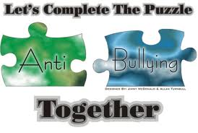

**School staff have a responsibility to:**

- respect and support students;

- model and promote appropriate behaviours;

- respond in a timely manner to incidents of bullying in the classroom and the playground according to the school’s anti-bullying plan,

- recording incidents using the restorative justice system;

- through the Bounce Back program we teach social skills and anti-bullying strategies to develop an understanding of bullying and its impact on individuals and the broader community; and

- record any interventions regarding bullying and what a teacher is doing on the student welfare database.

**Students have a responsibility to:**

- behave appropriately, respecting individual differences and diversity;

- follow this anti-bullying plan; and

- report incidents of bullying according to their school anti-bullying plan.

# What is bullying?

Bullying is a ***sustained intentional   
behaviour*** by an individual or group of individuals that causes upset, distress, hurt,   
or an intense sense of fear.

Bullying involves intentional and willful   
misuse of power in relationships.

Bullying often seems to involve direct or   
indirect harassment, humiliation, violent or physical domination and or intimidation of   
others.

**Bullying may be:**- **physical** (hitting, kicking, pinching);

**- verbal** (name-calling, teasing);  
- **psychological** (stand over tactics, gestures);  
- **social** (exclusion and ignoring others); or  
- **emotional** (rumours, putdowns)

- may be done directly (e.g. face to face) or indirectly (e.g. via mobiles or the internet- cyber bullying);

- may be motivated by jealousy, distrust,   
fear, misunderstanding or lack of knowledge;

- has an element of threat; and

- can continue over time.

refer to the attached bullying behaviours chart to further your knowledge as to what may constitute bullying.

[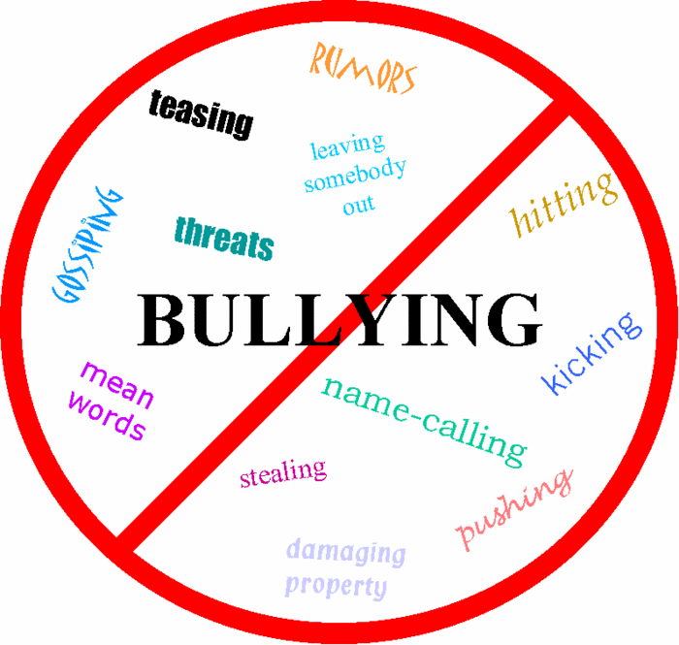](http://www.glogster.com/media/1/8/85/85/8858563.gif)